Name: Santhosh M R S
Register no: RA2611003020184
TASK 2: CORE SECURITY CONCEPTS
Cybersecurity Fundamentals Through Real-Life Situations
Cybersecurity protects information and digital systems from unauthorized access, unwanted changes, service disruption, and misuse. The following examples use everyday situations from hospitals, colleges, banking, workplaces, and messaging services.
1. Confidentiality — Meaning: Confidentiality means sensitive information should be visible only to people who have a genuine reason and permission to access it.
Real-Life Scenario: At a hospital, a receptionist needs a patient’s appointment details but should not be able to open the patient’s complete medical history. If the hospital system lets the receptionist view diagnosis reports or other patients’ records, private information has been exposed. Role-Based Access Control (RBAC) can limit each employee to the records needed for their job.

Realistic visual: Hospital employee accessing patient records with role-based restrictions.
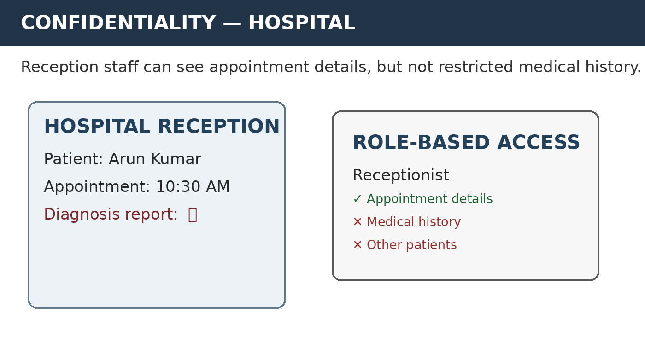
Why it matters: It protects personal information such as medical records, identity details, financial information, and confidential business data from unauthorized viewing.
Page 1 of 5

Name: Santhosh M R S
Register no: RA2611003020184
2. INTEGRITY
Meaning: Integrity means information remains accurate, complete, and trustworthy. Only authorized people or systems should be able to modify it.
Real-Life Scenario: A college student checks the online examination portal and sees that a subject grade has changed from B to A even though the faculty member did not make the change. An unauthorized alteration has affected the academic record. Audit logs, access controls, database permissions, and change history can help detect and investigate such modifications.

Realistic visual: College student portal showing an academic record after an unauthorized change.
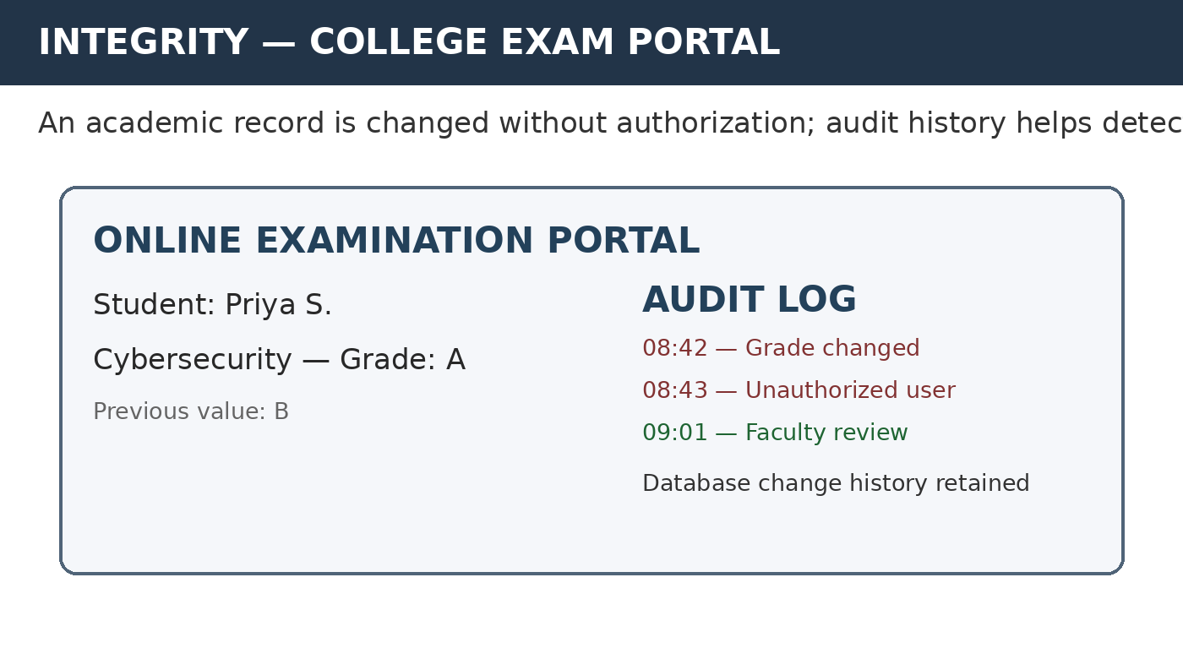
Why it matters: Integrity helps students, employees, banks, hospitals, and other organizations trust that important records have not been secretly or incorrectly changed.
Page 2 of 5

Name: Santhosh M R S
Register no: RA2611003020184
3. AVAILABILITY
Meaning: Availability means authorized users can access a service or system when they need it. A system may have secure data but still fail the availability requirement if the service cannot be reached.
Real-Life Scenario: During a busy period, an online banking service is flooded with huge amounts of unwanted traffic. Genuine customers repeatedly receive a “Service Unavailable” message and cannot check balances or make payments. This can happen during a DDoS attack or another major service overload. DDoS protection, traffic filtering, load balancing, backups, and resilient infrastructure can reduce the impact.

Realistic visual: Customer unable to reach an online banking service during a service disruption.
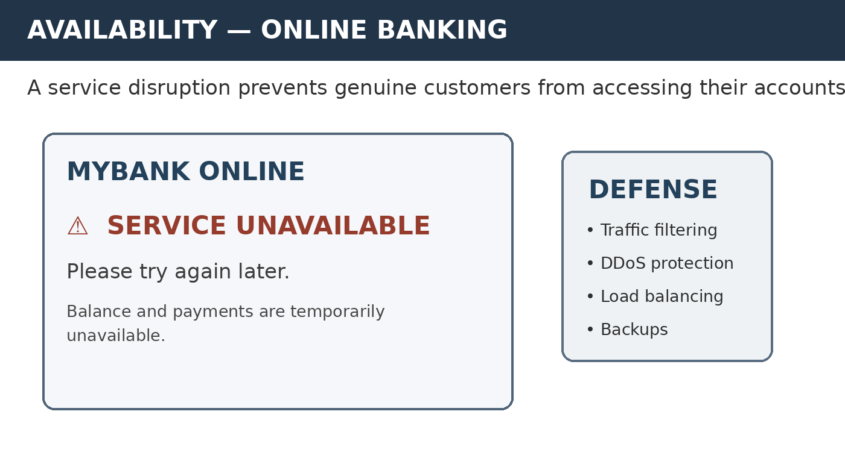
Why it matters: Availability is essential for banking, healthcare, transport, education, emergency services, and any system that people depend on at a particular time.
Page 3 of 5

Name: Santhosh M R S
Register no: RA2611003020184
4. AUTHENTICATION VS. AUTHORIZATION
Meaning: Authentication answers “Who are you?” Authorization answers “What are you allowed to access or do?” A user can successfully prove their identity and still be denied access to certain resources.
Real-Life Scenario: An employee signs in to a company’s shared drive with a valid username, password, and possibly a second factor such as an OTP. The login system confirms the employee’s identity — authentication. When the employee opens the HR salary folder, the system checks their permissions and displays “Access Denied” because that folder is restricted to HR staff — authorization.

Realistic visual: Successful employee login followed by a permission check for a restricted HR folder.
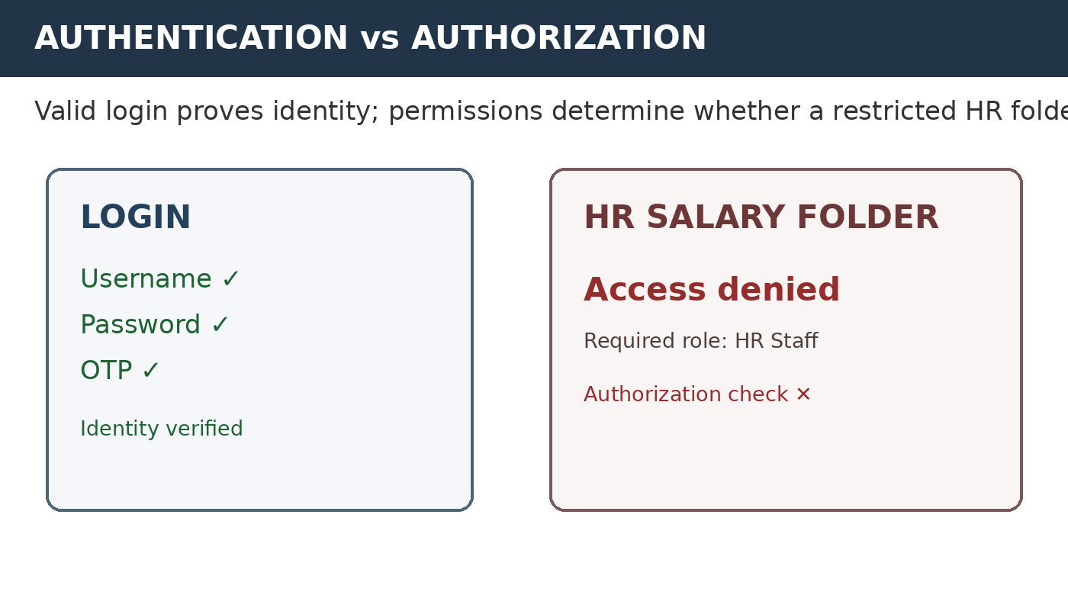
Why it matters: Separating identity verification from permissions helps organizations apply least-privilege access and prevents ordinary users from automatically gaining access to sensitive resources.
Page 4 of 5

Name: Santhosh M R S
Register no: RA2611003020184
5. ENCRYPTION VS. HASHING
Meaning: Encryption transforms readable information into protected data that can be recovered with the appropriate key. Hashing converts input into a fixed-length value and is designed to be one-way.
Real-Life Scenario: When a person sends a private message through an end-to-end encrypted messaging service, encryption helps protect the message while it travels between devices. Passwords are handled differently: a well-designed website stores a salted password hash rather than the original password. During login, the entered password is processed and compared with the stored verification value instead of recovering the original password.

Realistic visual: Encrypted message communication compared with one-way password hashing.
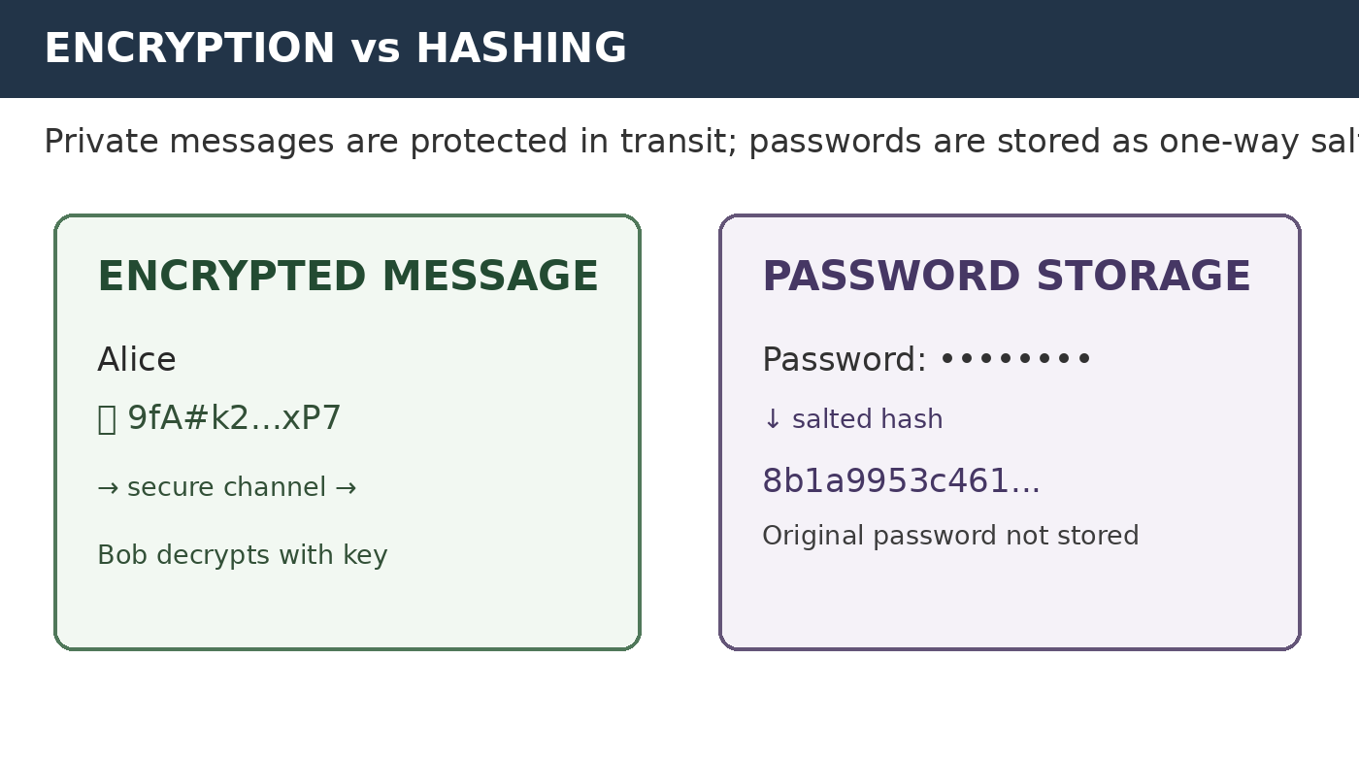
Why it matters: Encryption helps protect information during communication or storage, while password hashing reduces the risk of exposing original passwords if a password database is compromised.
Conclusion: Confidentiality, Integrity, and Availability form the CIA Triad, a basic foundation of cybersecurity. Authentication and authorization control identity and access, while encryption and hashing protect information in different ways. Together, these concepts help keep digital services trustworthy in real-world situations.
Page 5 of 5

